Name:- Utsav Sharma . Id:-CZT240357.

Task :-1

Deployment of the hello world function on the aws lambda

Step1) Open the aws console home:-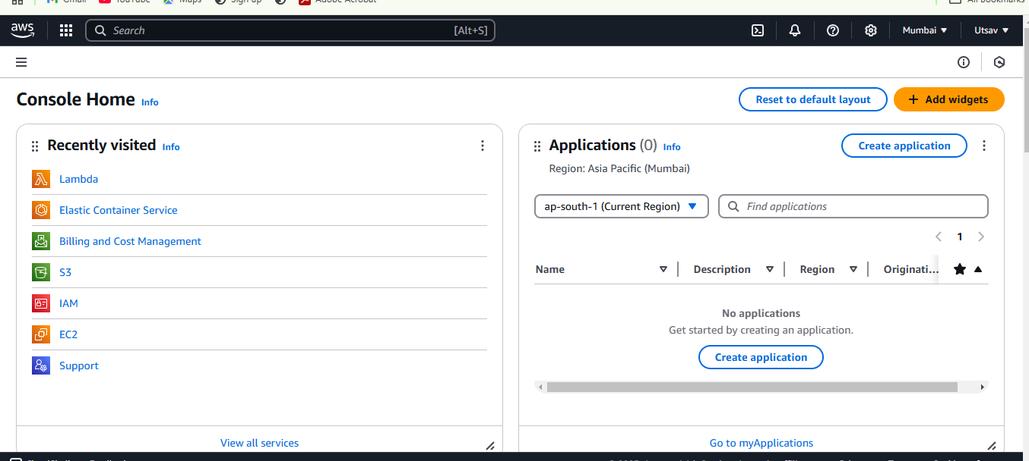

2)Select the Lambda

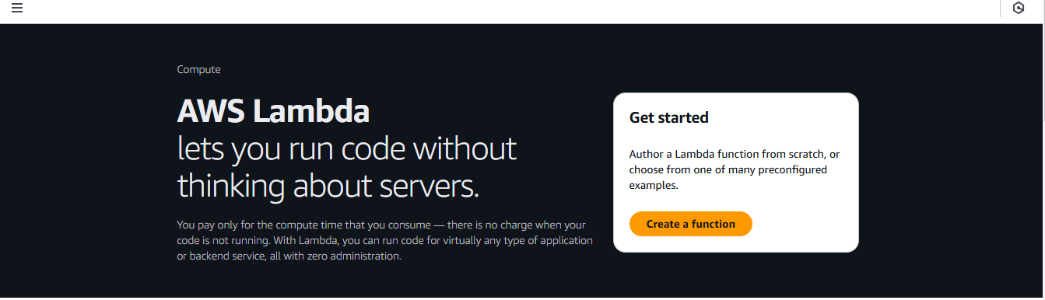

3) creation of the lambda function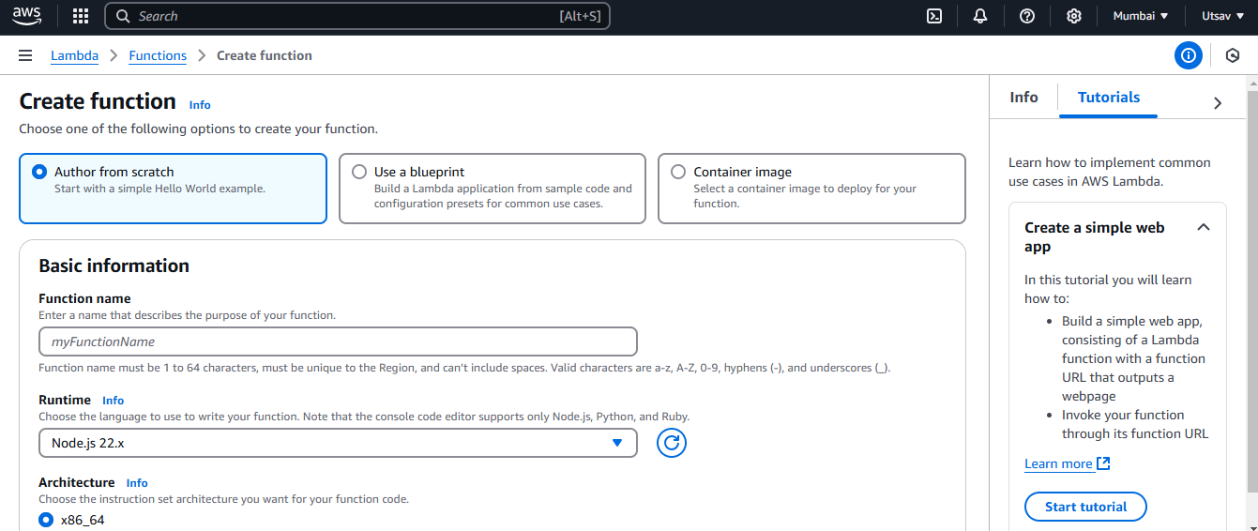

Name:-helloworld

Role:- Create new role from templetes(s)

Role name:-myrole1

Policy templetes :- Simple Microservices permissions

Function code is node.js

Press the Create function

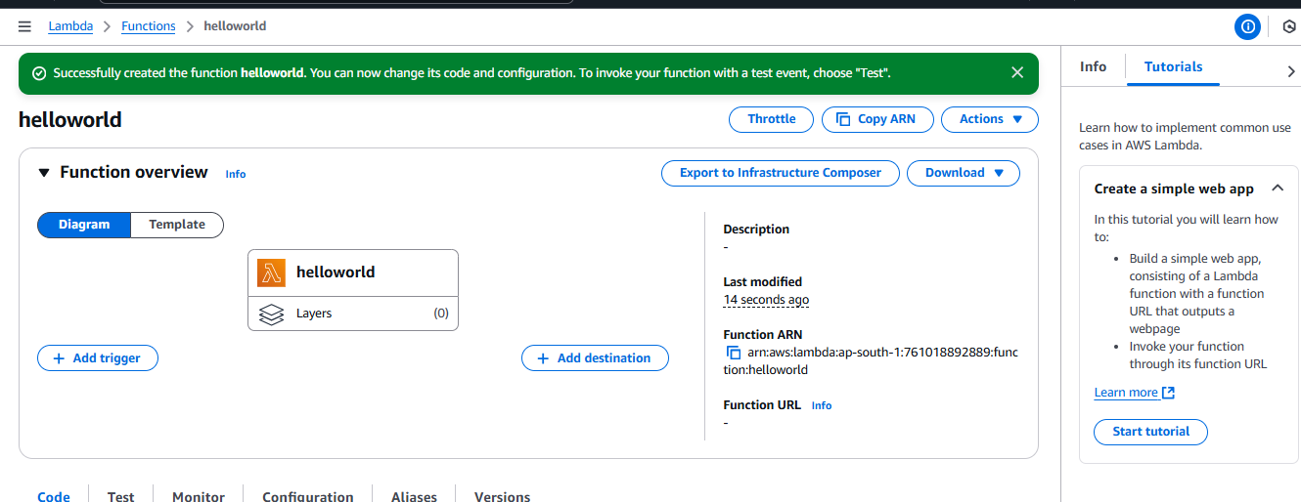

4) create the test event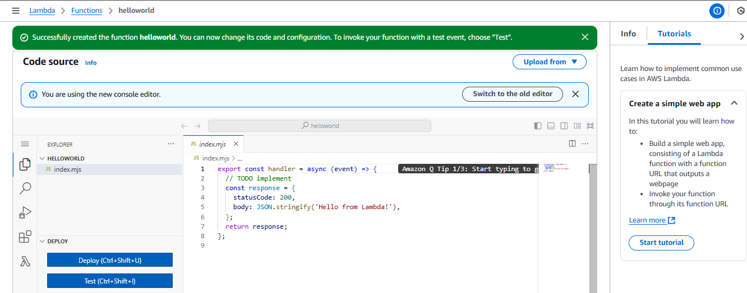

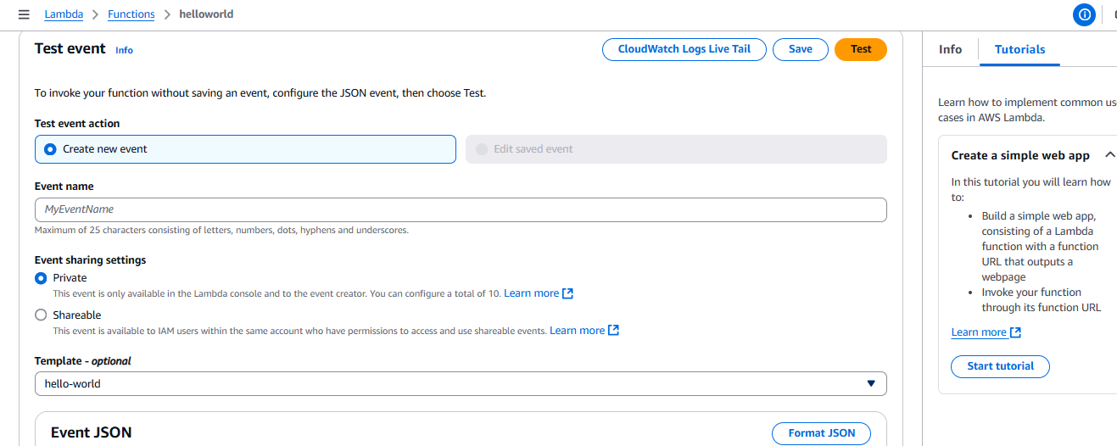

5) changes in mytestevent :- key1:”hello world!” then save

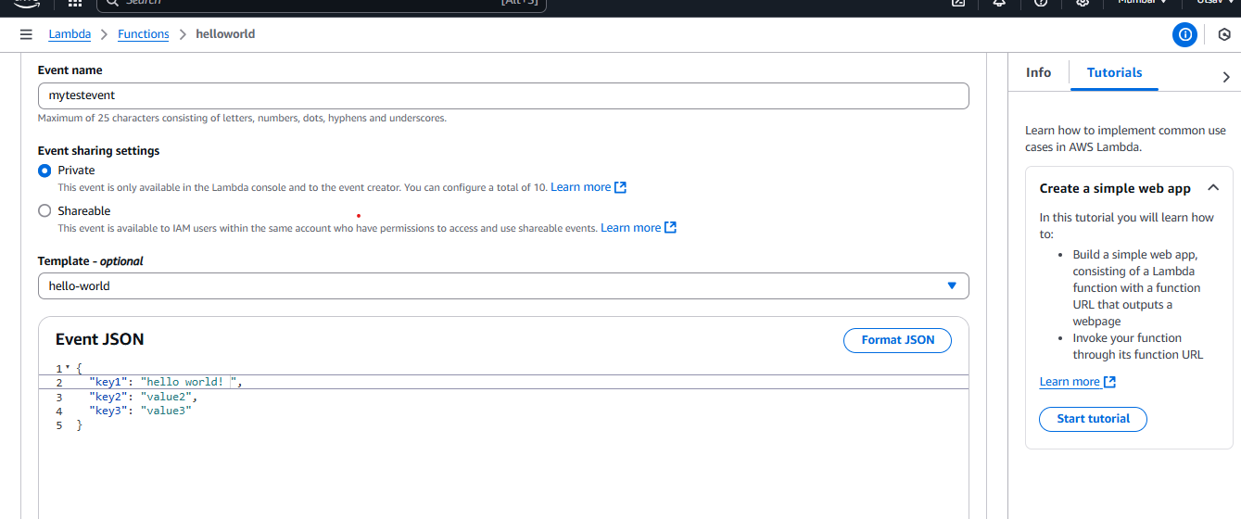

6) node.js code :- (“key1 value is “+ event.key1)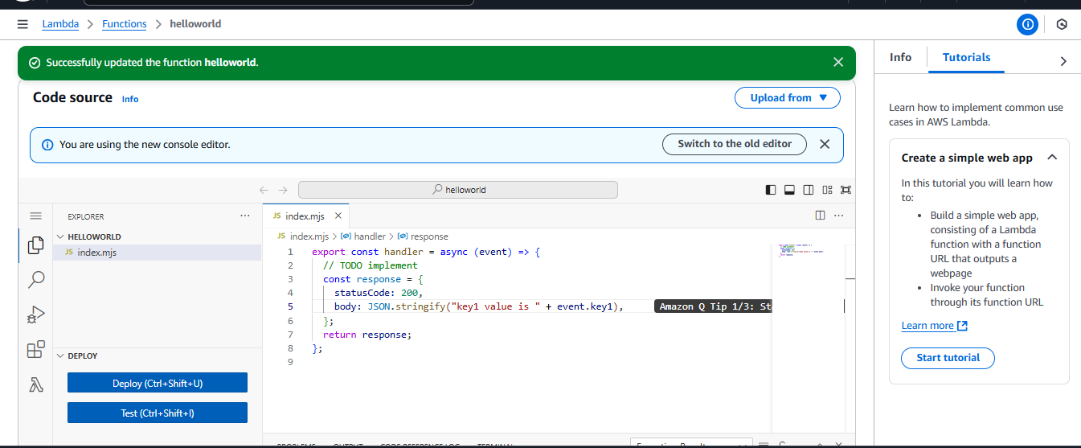

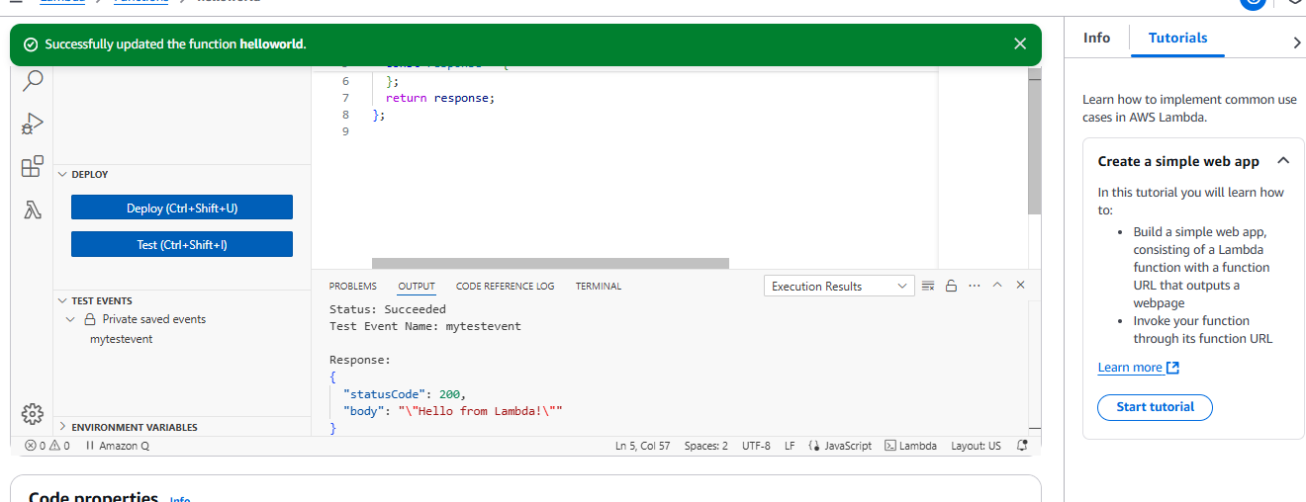

7) click on deployment

